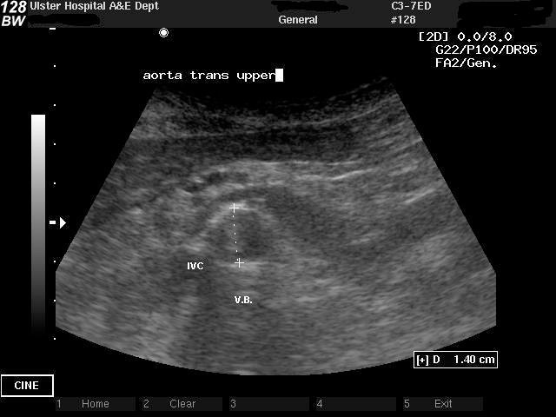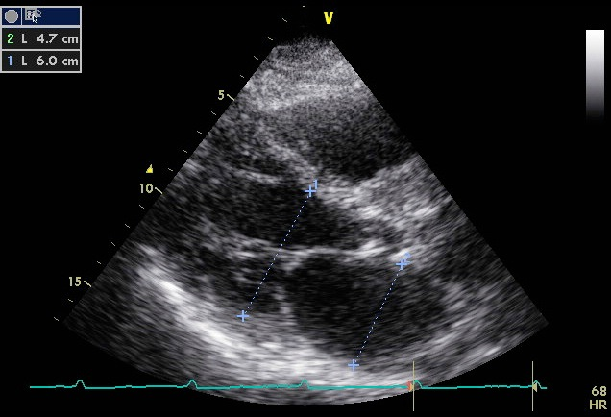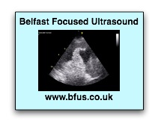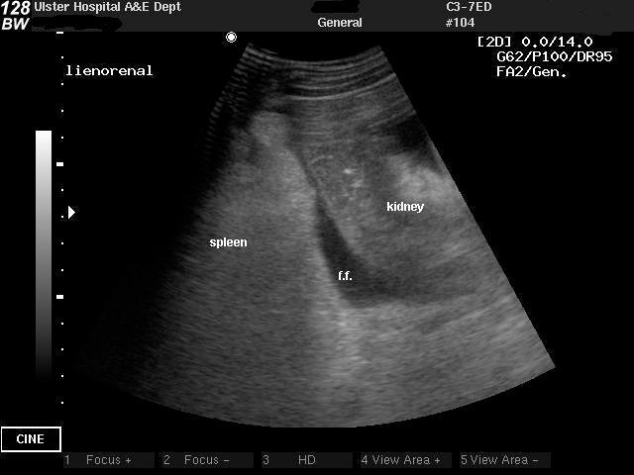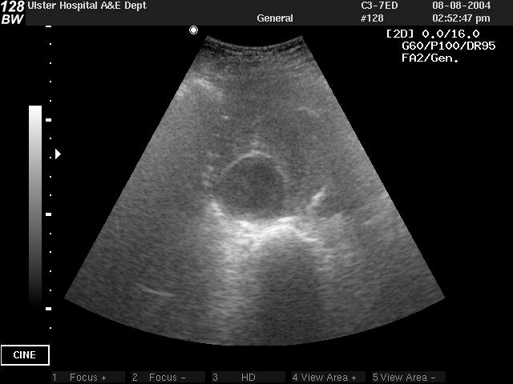

**Workshop in**

**Emergency / Critical Care Ultrasound**

**Friday 18th October 2019**

This 1 day workshop is aimed at practitioners in all acute specialties with limited or no experience in Emergency Ultrasound. It will comprise of a balanced mix of lectures and practical sessions, and is recognised by the College of Emergency Medicine as appropriate for core competency as defined in the specialty curriculum. Approved for RCoA 5 points CPD.

Faculty are experienced in the use and teaching of Emergency Ultrasound, and are senior practitioners with extensive experience in Emergency Ultrasound in the specialties of

Emergency Medicine and Critical care.

Topics covered will include FAST; AAA detection; Vascular Access; ECHO in life support, and pleural scanning.

Workshops will give the opportunity to learn and practice techniques

on healthy volunteers and patients with relevant findings.

Places will be limited to 25 to maximise hands-on experience. Early booking is advised.

For further information and application form visit www.bfus.co.uk

or contact Liz Dunlop (Course secretary), 25 Ardvanagh Road Conlig BT23 7XA

Email: [Lizdunlop23@hotmail.com](mailto:Lizdunlop23@hotmail.com) or niall.collum@setrust.hscni.net

**QIIC**

**The Ulster Hospital,**

**Dundonald,**

**Belfast**

**Course Fee £190**