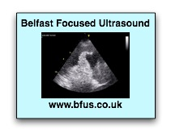
Workshop in
Emergency/ Critical Care
Ultrasound
QIIC; Ulster Hospital; Dundonald.
Fri 9th November 2018

Registration Form

Name: _____________________________________

Contact Address: _____________________________________

_____________________________________

Email: _____________________________________

Contact Telephone: _____________________________________

Job Title: _____________________________________
(Grade & specialty)

Hospital: _____________________________________

Dietary Requirements: _____________________________________

Method of Payment: _____________________________________

I enclose a cheque for £190 made payable to “Belfast Focused Ultrasound”
OR: I have submitted online payment REFERENCED WITH MY NAME to:
Account: Belfast Focused Ultrasound Sort code: 93 82 70 Acc number: 02898025

Signed: _______________________ Date: _______________________________

In the event of oversubscription, names will be held on a waiting list for future courses, and the cheques will not be cashed.

Please send completed forms to – BFUS, c/o Liz Dunlop, 25 Ardvanagh Road, Conlig BT23 7XA or email with confirmation of bank transfer to Lizdunlop23@hotmail.com

Further details will be emailed to participants when available. For further information, contact Lizdunlop23@hotmail.com or niall.collum@setrust.hscni.net

